MODULE -3

Technical writing process.
The technical writing process involves creating clear, concise, and accurate documents that effectively communicate complex information to a specific audience. The process typically includes several stages, each crucial for producing high-quality technical documents. Here’s an overview of the technical writing process:

1. Planning
Purpose: Define the scope and objectives of the document.
- Identify Audience: Understand who will read the document and their level of expertise.
- Determine Purpose: Clarify the document’s goal (e.g., instructions, reports, manuals).
- Gather Information: Collect data from subject matter experts, research, and other sources.
- Outline Structure: Plan the document’s layout and organization (e.g., sections, headings).

2. Research and Analysis
Purpose: Collect and analyze the information needed to create the document.
- Conduct Research: Obtain relevant data, technical specifications, and industry standards.
- Analyze Requirements: Determine what information is necessary for the document’s purpose.
- Consult Experts: Collaborate with subject matter experts to ensure accuracy.

3. Drafting
Purpose: Write the initial version of the document.
- Follow Outline: Use the planned structure to organize content logically.
- Write Clearly: Use plain language, and define technical terms as needed.
- Focus on Accuracy: Ensure technical details are correct and up-to-date.
- Include Visuals: Add diagrams, charts, or screenshots if they help clarify content.

4. Reviewing and Revising
Purpose: Improve the document’s clarity, accuracy, and usability.
- Review for Content: Check for completeness, accuracy, and technical correctness.
- Revise for Clarity: Simplify complex sentences and jargon, and ensure the document flows logically.
- Edit for Style: Ensure consistency in formatting, terminology, and style.
- Proofread: Check for grammatical, spelling, and punctuation errors.

5. Testing
Purpose: Ensure the document meets user needs and performs as intended.
- Usability Testing: Have potential users test the document to ensure it’s easy to understand and use.
- Feedback Collection: Gather feedback from users and stakeholders to identify areas for improvement.
- Make Adjustments: Revise the document based on feedback and test results.

6. Finalizing
Purpose: Prepare the document for publication or distribution.
- Format: Ensure the document is properly formatted and adheres to any style guidelines.
- Include Metadata: Add any necessary metadata (e.g., version numbers, authorship).
- Prepare for Distribution: Convert the document to the required format (e.g., PDF, HTML) and distribute it to the intended audience.

7. Maintenance
Purpose: Keep the document up-to-date and relevant.
- Update Content: Regularly review and revise the document as necessary to reflect changes in information or technology.
- Track Changes: Maintain version control to track updates and changes.
- Solicit Feedback: Continue to gather user feedback and make improvements.

Tips for Effective Technical Writing
- Know Your Audience: Tailor the document to the knowledge level and needs of your readers.
- Be Concise: Avoid unnecessary jargon and provide information in a straightforward manner.
- Use Visuals: Include diagrams, charts, and screenshots to support and clarify textual information.
- Maintain Consistency: Use consistent terminology, formatting, and style throughout the document.
- Prioritize Accuracy: Double-check technical details and data to ensure precision.

Common Types of Technical Documents
- User Manuals: Guides for end-users on how to use a product or system.
- Technical Specifications: Detailed descriptions of technical requirements and design.
- Standard Operating Procedures (SOPs): Instructions for routine operations and processes.
- Reports: Documents summarizing research, findings, or project status.
- Proposals: Documents outlining project plans or requests for approval and funding.

Introduction to technical reports writing.
Technical report writing is a crucial skill for effectively communicating complex information and findings in a structured and professional manner. Technical reports are often used to present research results, project updates, or technical data to an audience that requires detailed and precise information.

Introduction to Technical Reports Writing

1. Purpose of Technical Reports
Technical reports serve several purposes, including:
- Documenting Findings: Reporting on research, experiments, or project results.
- Informing Decision-Making: Providing information to support business or technical decisions.
- Guiding Actions: Offering recommendations or instructions based on technical analysis.
- Compliance: Meeting regulatory or organizational reporting requirements.

2. Key Components of a Technical Report
A well-structured technical report typically includes the following sections:
- Title Page
  - Content: Title of the report, author's name, affiliation, date, and any relevant project or report number.
- Abstract
  - Purpose: Provides a brief summary of the report's objectives, methods, findings, and conclusions.
  - Length: Typically 150-250 words.
  - Tips: Write this section last, even though it appears first in the report.
- Table of Contents
  - Purpose: Lists the headings and subheadings along with page numbers to help readers navigate the report.
- List of Figures and Tables
  - Purpose: Lists all figures and tables included in the report, along with their page numbers.
- Introduction
  - Purpose: Introduces the topic, provides background information, and states the objectives or purpose of the report.
  - Content: Include the problem statement, scope, and significance of the study or project.
- Literature Review (if applicable)
  - Purpose: Summarizes relevant previous research or background information related to the report topic.
  - Content: Discuss existing knowledge, gaps, and how the current report addresses these gaps.
- Methodology
  - Purpose: Describes the methods and procedures used to conduct research or gather data.
  - Content: Include details on experimental design, data collection techniques, and analysis methods.
- Results
  - Purpose: Presents the findings of the research or project.
  - Content: Use tables, graphs, and charts to illustrate key data. Summarize findings without interpretation.
- Discussion
  - Purpose: Interprets the results and discusses their implications.
  - Content: Compare findings with expectations, explain any anomalies, and relate results to the problem or objectives.
- Conclusions
  - Purpose: Summarizes the key findings and their significance.
  - Content: Restate main results and their implications. Highlight any recommendations or potential future work.
- Recommendations (if applicable)
  - Purpose: Provides actionable suggestions based on the report’s findings.
  - Content: Clearly state each recommendation and justify it based on the results.
- References/Bibliography
  - Purpose: Lists all sources cited in the report.
  - Content: Follow a specific citation style (e.g., APA, IEEE).
- Appendices
  - Purpose: Includes supplementary material that supports the main text.
  - Content: Raw data, detailed calculations, additional figures, or extended explanations.

3. Writing Style and Tone
- Clarity and Precision: Use clear and precise language to avoid ambiguity. Avoid jargon unless necessary, and define technical terms when first used.
- Objectivity: Maintain a neutral and objective tone. Base conclusions and recommendations on evidence.
- Conciseness: Be concise but thorough. Avoid unnecessary details or verbosity.
- Consistency: Ensure consistency in terminology, formatting, and style throughout the report.

4. Steps in Writing a Technical Report
- Plan and Research
  - Gather and organize information. Outline the structure and content of the report.
- Draft
  - Write the initial draft based on the outline. Focus on getting all the necessary information down.
- Revise
  - Review and revise the draft for clarity, accuracy, and coherence. Ensure all sections are complete and logically organized.
- Edit and Proofread
  - Check for grammatical, spelling, and punctuation errors. Ensure formatting is consistent and professional.
- Finalize
  - Prepare the final version, incorporating any feedback or changes. Ensure all required sections are included and properly formatted.

5. Common Challenges and Tips
- Data Presentation: Use visuals (charts, graphs) effectively to present data. Ensure they are labeled clearly and referenced in the text.
- Technical Jargon: Balance the use of technical terms with explanations for non-specialist readers if needed.
- Length: Be concise yet comprehensive. Avoid including unnecessary information.

Examples of Technical Reports
- Research Report: Presents findings from scientific research or experiments.
- Project Report: Details the progress and results of a project.
- Feasibility Report: Evaluates the viability of a proposed solution or project.
Technical report writing requires attention to detail, accuracy, and clarity to ensure that complex information is communicated effectively.

Significance of reports.
Reports are vital tools in various fields and industries, serving multiple purposes by providing structured and detailed information. Their significance can be understood through several key aspects:

1. Decision-Making
Purpose: Reports provide data and analysis that support informed decision-making.
- Evidence-Based Decisions: By presenting accurate and relevant data, reports help stakeholders make decisions based on evidence rather than intuition.
- Risk Assessment: Reports often include risk analyses and recommendations, aiding in the evaluation of potential risks and benefits.
Example: A market research report provides data on consumer preferences, helping a company decide on product development or marketing strategies.

2. Communication
Purpose: Reports facilitate clear and effective communication within and outside organizations.
- Information Sharing: Reports convey information to stakeholders, team members, or the public, ensuring everyone has access to the same data and insights.
- Status Updates: They provide updates on progress, outcomes, or issues, keeping all parties informed about the current state of projects or operations.
Example: A project status report informs the management team about milestones achieved, challenges encountered, and next steps.

3. Documentation
Purpose: Reports serve as formal records of activities, research, or findings.
- Historical Record: They document the outcomes of studies, projects, or audits, creating a historical record that can be referenced in the future.
- Compliance: Reports often meet regulatory or organizational requirements, ensuring that activities are documented and compliant with standards.
Example: An audit report provides a record of financial practices and compliance, which can be reviewed during future audits.

4. Problem Solving
Purpose: Reports identify issues and propose solutions.
- Issue Identification: Through detailed analysis, reports can pinpoint problems or inefficiencies within systems or processes.
- Solution Proposals: They often include recommendations or action plans to address identified issues and improve performance.
Example: A technical troubleshooting report identifies the causes of system failures and suggests solutions to prevent future occurrences.

5. Accountability and Transparency
Purpose: Reports ensure accountability and transparency in operations and decision-making.
- Accountability: They hold individuals or teams accountable for their actions and outcomes by documenting their performance and decisions.
- Transparency: By providing detailed information on processes and results, reports enhance transparency and build trust with stakeholders.
Example: A financial report provides a clear view of an organization's financial health, allowing stakeholders to assess management's effectiveness and integrity.

6. Strategic Planning
Purpose: Reports support strategic planning by providing insights into trends, opportunities, and challenges.
- Trend Analysis: Reports analyze trends and patterns that inform strategic planning and forecasting.
- Opportunity Identification: They highlight potential opportunities for growth or improvement based on data analysis.
Example: A market analysis report identifies emerging trends and opportunities, helping businesses plan future strategies and investments.

7. Evaluation and Assessment
Purpose: Reports evaluate the effectiveness and outcomes of programs, projects, or policies.
- Performance Evaluation: They assess whether objectives have been met and evaluate performance against goals.
- Impact Assessment: Reports measure the impact of initiatives or interventions, providing insights into their success or areas for improvement.
Example: A program evaluation report assesses the effectiveness of a training program and provides recommendations for enhancing its impact.

8. Knowledge Sharing and Learning
Purpose: Reports contribute to knowledge sharing and organizational learning.
- Best Practices: They document best practices, lessons learned, and successful strategies that can be shared within and outside the organization.
- Continuous Improvement: Reports facilitate continuous improvement by reflecting on past experiences and providing insights for future endeavors.
Example: A case study report shares lessons learned from a successful project, helping other teams replicate success.

Summary
In summary, reports are significant because they:
- Facilitate Informed Decision-Making: Provide the necessary data and analysis for making informed decisions.
- Enhance Communication: Ensure clear and effective communication of information.
- Serve as Documentation: Create formal records of activities, research, and compliance.
- Aid in Problem Solving: Identify issues and propose actionable solutions.
- Promote Accountability and Transparency: Ensure accountability and build trust with stakeholders.
- Support Strategic Planning: Provide insights into trends and opportunities for strategic planning.
- Enable Evaluation and Assessment: Evaluate performance and impact.
- Contribute to Knowledge Sharing: Share best practices and support organizational learning.
Reports are essential tools for organizing and presenting information in a way that supports decision-making, communication, and continuous improvement.

Types of reports. Reports come in various types, each serving a specific purpose and tailored to different audiences and needs. Here’s an overview of the most common types of reports and their characteristics:

**1. Research Report
Purpose: To present the results of a research study or investigation.
- Contents: Introduction, literature review, methodology, results, discussion, conclusion, references.
- Usage: Used in academic, scientific, and technical contexts to share findings from research.
Example: A research report on the effects of a new drug on blood pressure.

**2. Technical Report
Purpose: To provide detailed information on technical or scientific processes, designs, or results.
- Contents: Title page, abstract, introduction, methodology, results, discussion, conclusion, recommendations, references, appendices.
- Usage: Common in engineering, IT, and scientific fields to document technical work and findings.
Example: A technical report detailing the design and performance of a new software application.

**3. Progress Report
Purpose: To update stakeholders on the status of a project or task.
- Contents: Introduction, current status, achievements, challenges, next steps, timeline.
- Usage: Used to track and communicate progress in ongoing projects or initiatives.
Example: A progress report on the development of a new marketing campaign.

**4. Project Report
Purpose: To summarize the results and outcomes of a project upon completion.
- Contents: Title page, executive summary, project objectives, methodology, results, discussion, conclusion, recommendations, lessons learned.
- Usage: Used for documenting the outcomes of a project and evaluating its success.
Example: A project report on the implementation of a new customer relationship management (CRM) system.

**5. Annual Report
Purpose: To provide a comprehensive overview of an organization's performance and financial status over the past year.
- Contents: Letter from the CEO, financial statements, operational highlights, future outlook, auditor’s report.
- Usage: Commonly used by businesses and nonprofits to communicate with shareholders, stakeholders, and the public.
Example: A company’s annual report detailing its financial performance, key achievements, and strategic goals.

**6. Financial Report
Purpose: To present an organization's financial status and performance.
- Contents: Balance sheet, income statement, cash flow statement, notes to financial statements.
- Usage: Used by organizations to report financial performance to stakeholders, including investors and regulatory bodies.
Example: A quarterly financial report showing earnings, expenses, and financial health.

**7. Audit Report
Purpose: To provide an independent assessment of an organization's financial records or operational processes.
- Contents: Auditor’s opinion, financial statements, compliance findings, recommendations.
- Usage: Used to ensure compliance with regulations and to provide assurance on financial accuracy.
Example: An audit report assessing a company’s adherence to accounting standards.

**8. Feasibility Report
Purpose: To evaluate the viability of a proposed project or solution.
- Contents: Introduction, project description, feasibility analysis, cost-benefit analysis, recommendations.
- Usage: Used to determine whether a project or solution is feasible and worth pursuing.
Example: A feasibility report analyzing the potential for opening a new branch office.

**9. Incident Report
Purpose: To document and analyze specific incidents or events.
- Contents: Incident description, date and time, parties involved, impact, investigation findings, corrective actions.
- Usage: Used in various settings, including workplace safety and security, to document and address incidents.
Example: An incident report detailing a workplace accident and its contributing factors.

**10. Executive Summary
Purpose: To provide a brief summary of a larger report or document.
- Contents: Key findings, conclusions, and recommendations.
- Usage: Used to give busy executives or stakeholders a quick overview of a detailed report.
Example: An executive summary of a market research report highlighting the main findings and recommendations.

**11. Incident Report
Purpose: To document specific events or incidents, typically for analysis or corrective action.
- Contents: Incident details, date and time, involved parties, impact, corrective actions.
- Usage: Used to record and investigate incidents such as accidents, security breaches, or other notable events.
Example: A workplace safety incident report describing an accident and the subsequent safety measures implemented.

**12. Case Study Report
Purpose: To explore and analyze a specific instance or case in detail.
- Contents: Case background, problem statement, analysis, findings, conclusions, recommendations.
- Usage: Used to provide in-depth insights into a particular case, often used for educational or research purposes.
Example: A case study report analyzing the implementation of a new business strategy at a company.

**13. Status Report
Purpose: To provide an update on the status of a specific project, task, or initiative.
- Contents: Overview, current status, milestones, issues, next steps.
- Usage: Used to keep stakeholders informed about the progress and current state of a project or task.
Example: A weekly status report on the development progress of a new software feature.

**14. Maintenance Report
Purpose: To document maintenance activities and their outcomes.
- Contents: Maintenance tasks performed, equipment or systems serviced, issues encountered, future maintenance plans.
- Usage: Used in industries such as manufacturing and facilities management to track maintenance activities.
Example: A maintenance report detailing the routine servicing of machinery in a manufacturing plant.

**15. Compliance Report
Purpose: To document adherence to regulatory or organizational standards and requirements.
- Contents: Compliance status, findings, areas of non-compliance, corrective actions.
- Usage: Used to demonstrate compliance with laws, regulations, or internal policies.
Example: A compliance report for an environmental regulation audit showing adherence to sustainability practices.

**16. Survey Report
Purpose: To present the results of a survey or questionnaire.
- Contents: Survey objectives, methodology, data analysis, findings, conclusions.
- Usage: Used to summarize and interpret survey results, often for market research or feedback purposes.
Example: A survey report summarizing employee satisfaction survey results and suggesting improvements.

Summary
Different types of reports serve various purposes and audiences, from documenting research and tracking progress to ensuring compliance and providing strategic insights. Each type has its own structure and content requirements tailored to its specific objectives and use cases.

Introduction to technical proposals writing
Technical proposal writing is the process of creating documents that propose a solution to a technical problem or outline a plan for a technical project. These proposals are typically submitted to clients, funding agencies, or internal stakeholders to secure support, approval, or funding.

Purpose of a Technical Proposal
A technical proposal serves to:
- Identify a problem or need
- Propose a specific solution or method
- Justify the approach with technical details and benefits
- Demonstrate feasibility (technical, financial, and logistical)
- Request resources, approval, or partnership

Key Elements of a Technical Proposal
- Title Page
  - Project title
  - Proposer's name/organization
  - Date
  - Recipient (client or reviewer)
- Executive Summary
  - A concise overview of the proposal, highlighting the problem, solution, and benefits
- Introduction
  - Context and background
  - Purpose of the proposal
  - Scope of the project
- Problem Statement
  - Clear definition of the problem or need being addressed
- Proposed Solution / Technical Approach
  - Detailed explanation of the proposed methodology, technology, or product
  - Diagrams, charts, or flowcharts if applicable
- Objectives and Deliverables
  - Measurable goals and what will be delivered
- Timeline / Project Schedule
  - Phases of work, milestones, and deadlines
- Budget / Cost Estimate
  - Breakdown of costs: materials, labor, overhead, etc.
- Qualifications
  - Team experience, technical capabilities, past similar projects
- Conclusion
  - Final persuasive summary, restating the value and asking for approval or funding
- Appendices
  - Additional technical details, resumes, references, or data

Characteristics of a Good Technical Proposal
- Clarity: Clear and jargon-free where possible
- Conciseness: No unnecessary details
- Accuracy: Precise technical and financial information
- Persuasiveness: Justifies the approach and builds confidence
- Organization: Easy to follow with headings and logical flow

Tips for Effective Proposal Writing
- Know your audience – tailor the level of technical detail accordingly.
- Follow the RFP (Request for Proposal) instructions carefully.
- Use visuals to clarify complex concepts.
- Revise and proofread – technical accuracy and grammar are both critical.
- Highlight the benefits and feasibility of your solution.

Types of technical proposals

Types of Technical Proposals
Technical proposals vary in type depending on the purpose, audience, and how they are initiated. Here are the main types:

1. Solicited Proposals
These are submitted in response to a formal request such as a Request for Proposal (RFP), Request for Quotation (RFQ), or Invitation to Bid (ITB).
- Characteristics:
  - Follows specific guidelines provided by the client or agency
  - Often competitive (multiple parties submit proposals)
  - Must address every requirement in the RFP
- Examples:
  - A software company responding to a government RFP for a custom database system

2. Unsolicited Proposals
These are submitted without a direct request from the client or organization. They are usually sent to suggest a solution or innovation the client may not be aware of.
- Characteristics:
  - Initiated by the proposer
  - Requires strong persuasive elements to capture interest
  - Less structured than solicited proposals
- Examples:
  - An engineering firm proposing a new energy-efficient HVAC system to a commercial building owner

3. Pre-Proposals (White Papers or Concept Papers)
These are shorter versions of full proposals used to gauge interest or seek initial feedback before submitting a complete proposal.
- Characteristics:
  - Focuses on the concept or problem-solution overview
  - Often used in government or research funding environments
  - Helps avoid wasted effort on full proposals that may not be accepted
- Examples:
  - A university researcher submitting a white paper on climate modeling to a funding agency

4. Continuation or Renewal Proposals
These request continued funding or project extension after the original proposal has been approved.
- Characteristics:
  - Shows progress and results of the original project
  - Justifies the need for ongoing work or additional funding
- Examples:
  - A nonprofit requesting continued support for a technology training program

5. Supplemental Proposals
These request additional resources for an already approved project due to new requirements or unforeseen changes.
- Characteristics:
  - Must explain the reason for additional needs
  - Includes updated timelines and budgets
- Examples:
  - A construction firm requesting additional funding after unexpected site conditions increase costs

6. Internal Proposals
These are used within an organization to propose projects, improvements, or purchases that require management approval.
- Characteristics:
  - Audience is internal (e.g., department heads, executives)
  - Often less formal but still structured
- Examples:
  - An IT department proposing a new cybersecurity system to company leadership

Characteristics of technical proposals
A well-crafted technical proposal has distinct characteristics that set it apart from other types of proposals or business documents. These features ensure that the proposal effectively communicates technical ideas while persuading the reader to approve or fund the project.

1. Clarity and Precision
- Uses clear, unambiguous language
- Defines technical terms and avoids unnecessary jargon
- Presents complex information in a straightforward manner

2. Structured and Well-Organized
- Follows a logical format (e.g., introduction → problem → solution → budget → conclusion)
- Uses headings, subheadings, bullet points, and tables for easy navigation
- Includes all required sections (per the RFP or standard proposal format)

3. Objective and Evidence-Based
- Relies on data, facts, calculations, and analysis—not opinions
- Includes evidence such as case studies, test results, references, or simulations to support claims

4. Persuasive yet Professional
- Builds a compelling case for the proposed solution
- Highlights the benefits and feasibility of the project
- Maintains a formal, respectful tone

5. Technically Detailed
- Provides sufficient technical depth to show understanding and capability
- Includes schematics, models, timelines, materials, methods, etc.
- May include appendices for supplementary technical data

6. Tailored to the Audience
- Adjusts the level of detail based on whether the audience is technical or non-technical
- Addresses the client’s specific needs, goals, and constraints

7. Goal-Oriented
- Focuses on solving a defined problem or meeting a specific need
- Clearly outlines objectives, deliverables, and success metrics

8. Feasibility-Focused
- Demonstrates that the project is doable within the proposed timeline, budget, and resources
- Considers risks and includes mitigation strategies

9. Budget-Conscious
- Includes a realistic, detailed cost estimate
- Justifies expenses and shows efficient use of resources

10. Deadline-Driven
- Provides a clear project schedule with milestones and timelines
- Aligns with client deadlines or funding cycle requirements

Scientific writing process
Scientific writing is the structured and objective communication of research findings, typically for academic or professional audiences. The process helps ensure clarity, accuracy, and reproducibility. Here’s a breakdown of the scientific writing process, from planning to final revisions:

1. Planning and Preparation

a. Identify the Purpose
- Are you writing a research paper, a report, a thesis, or a journal article?
- What question or hypothesis are you addressing?

b. Know Your Audience
- Are you writing for scientists in your field, a general audience, or a funding agency?
- Adjust technical language and background detail accordingly.

c. Review the Literature
- Conduct a thorough review of related work.
- Identify gaps your research addresses.
- Collect references for citation.

2. Conduct the Research
(If applicable)
- Use appropriate scientific methods.
- Keep detailed notes of methods, observations, and results.
- Ensure accuracy and reproducibility.

3. Organize the Structure
Most scientific papers follow the IMRaD format:

I – Introduction
- Background and context
- Research question or hypothesis
- Objectives and significance

M – Methods
- Experimental or study design
- Materials, tools, and procedures
- Data collection and analysis methods

R – Results
- Present findings clearly (tables, figures, text)
- Avoid interpretation (just present facts)

a – and
(Connects results to discussion.)

D – Discussion
- Interpret the results
- Compare with existing studies
- Explain implications and limitations
- Suggest future research

Other Key Sections:
- Abstract – A summary of the entire paper
- Conclusion – Highlights key findings and relevance
- References – All sources cited properly
- Acknowledgments – Optional; thank funders or collaborators

4. Writing the First Draft
- Write each section in logical order (many start with Methods or Results first).
- Be concise and objective.
- Use scientific tone and terminology.
- Avoid bias or exaggeration.

5. Revising and Editing

a. Content Revision
- Is the argument clear and well-supported?
- Are all claims backed by data?
- Are methods and results complete?

b. Clarity and Style
- Short, precise sentences
- Use of active voice (where appropriate)
- Avoid redundancy

c. Grammar and Format
- Check spelling, punctuation, and grammar
- Follow the style guide (APA, MLA, IEEE, etc.)
- Format figures, tables, and citations correctly

6. Peer Review and Feedback
- Share with colleagues, mentors, or supervisors
- Consider peer review if submitting to a journal
- Revise based on feedback

7. Finalization and Submission
- Ensure all formatting, citations, and sections meet the requirements
- Prepare cover letter or abstract if needed
- Submit to journal, conference, or organization

Voice
n writing, "voice" refers to the distinct personality, style, and tone that an author conveys through their text. It reflects the author's attitude and perspective, and it can greatly affect how the reader perceives the content. There are several aspects of voice to consider:

**1. Author's Voice
Purpose: To express the unique personality and perspective of the writer.
- Characteristics: Includes the choice of words, sentence structure, tone, and overall style. It can be formal, informal, conversational, academic, or professional, depending on the context and audience.
- Impact: Helps readers connect with the writer’s message and understand their viewpoint. It adds authenticity and engages the audience.
Example: An author’s voice in a personal blog might be informal and conversational, while in a scholarly article, the voice would be formal and objective.

**2. Narrative Voice
Purpose: To shape how a story is told and from what perspective.
- First-Person Narration: The narrator is a character within the story, using "I" or "we." This perspective provides personal insight and direct access to the narrator’s thoughts and feelings.
- Second-Person Narration: The narrator addresses the reader as "you." This is less common but can create a unique and immersive experience.
- Third-Person Narration: The narrator is outside the story, using "he," "she," "they," or "it." This can be omniscient (knowing all characters' thoughts) or limited (focusing on one character's perspective).
Example: In J.K. Rowling's Harry Potter series, the third-person limited perspective focuses on Harry’s experiences, providing insight into his thoughts and emotions.

**3. Tone
Purpose: To convey the writer's attitude towards the subject matter.
- Characteristics: Tone can be serious, humorous, sarcastic, optimistic, or critical, among others. It is shaped by word choice, sentence structure, and overall writing style.
- Impact: Tone influences how the reader interprets the message and affects their emotional response.
Example: A report written with a formal tone will use professional language and a respectful attitude, whereas a review with a sarcastic tone might use irony and humor to critique a subject.

**4. Style
Purpose: To determine how the writer’s voice is expressed through writing conventions.
- Characteristics: Style includes aspects like diction (word choice), syntax (sentence structure), punctuation, and overall organization.
- Impact: A consistent style helps establish the writer’s voice and makes the text more engaging and readable.
Example: Ernest Hemingway’s style is known for its simplicity and directness, while James Joyce’s style is characterized by complex sentence structures and stream-of-consciousness techniques.

**5. Active vs. Passive Voice
Purpose: To describe the relationship between the subject and the action in a sentence.
- Active Voice: The subject performs the action (e.g., "The researcher conducted the experiment"). This often makes sentences clearer and more direct.
- Passive Voice: The action is performed on the subject (e.g., "The experiment was conducted by the researcher"). This can be useful when the focus is on the action or the recipient of the action rather than who performs it.
Example: "The team completed the project on time" (active) vs. "The project was completed on time by the team" (passive).

**6. Voice in Different Genres
Purpose: To adapt the voice to fit the genre and audience of the writing.
- Creative Writing: Voice can be expressive and imaginative, tailored to fit the narrative style and character perspectives.
- Technical Writing: Voice is typically clear, concise, and objective, focusing on delivering information effectively.
- Academic Writing: Voice is formal and authoritative, emphasizing evidence-based arguments and scholarly tone.
Example: In a novel, the voice might be rich and descriptive, while in a technical manual, the voice will be straightforward and utilitarian.

Summary
Voice in writing encompasses the author’s unique style, tone, and perspective. It shapes how content is perceived and engages the reader, whether through narrative, tone, or stylistic choices. Understanding and developing an effective voice is crucial for impactful communication in any form of writing.

Active and passive voice are two different ways to structure sentences, and they can impact clarity and emphasis in writing. Here’s a detailed breakdown of both:

Active Voice
Definition: In active voice, the subject of the sentence performs the action expressed by the verb.
Structure:
- Subject + Verb + Object
- Example: "The chef (subject) cooked (verb) the meal (object)."
Characteristics:
- Clarity: Active voice tends to be clearer and more direct, making it easier for readers to understand who is doing what.
- Engagement: It often makes sentences more engaging and dynamic.
- Emphasis: Places emphasis on the subject performing the action.
When to Use:
- In most writing: Especially in essays, articles, and reports where clarity and directness are important.
- To highlight the actor: When the identity of the person or entity performing the action is important.
Example Sentences:
- "The scientist conducted the experiment."
- "The team completed the project ahead of schedule."
- "The teacher explains the concept clearly."

Passive Voice
Definition: In passive voice, the subject of the sentence is acted upon by the verb, and the focus shifts to the action or the recipient of the action rather than who performed it.
Structure:
- Object + Form of 'to be' + Past Participle + (by Subject)
- Example: "The meal (object) was cooked (verb) by the chef (subject)."
Characteristics:
- Focus: Emphasizes the action or the recipient of the action rather than who is performing it.
- Formality: Often used in formal writing and scientific contexts where the action or result is more important than the actor.
- Complexity: Can sometimes make sentences more complex or less direct.
When to Use:
- To emphasize the action or result: When the action or the recipient is more important than the actor.
- When the actor is unknown or irrelevant: If the doer of the action is not known or is less important.
- In formal or scientific writing: Where the focus is often on the process or results rather than the individual performing the action.
Example Sentences:
- "The experiment was conducted by the scientist."
- "The project was completed ahead of schedule by the team."
- "The concept is explained clearly by the teacher."

Comparison and Considerations
Active Voice:
- Pros: Direct, concise, and often more engaging. Easier to understand who is doing what.
- Cons: Might be less suitable in situations where the focus should be on the action or the result rather than the actor.
Passive Voice:
- Pros: Useful for emphasizing the action or result. Can be helpful when the actor is unknown or irrelevant.
- Cons: Can make sentences longer and more complex. May obscure who is performing the action, leading to potential ambiguity.

Transforming Between Voices
- Active to Passive: Identify the object of the active sentence, move it to the subject position, and use a form of "to be" plus the past participle of the verb.
  - Active: "The committee approved the proposal."
  - Passive: "The proposal was approved by the committee."
- Passive to Active: Identify the doer of the action, place it in the subject position, and adjust the verb and object accordingly.
  - Passive: "The proposal was approved by the committee."
  - Active: "The committee approved the proposal."

Summary
Active and passive voice each have their place in writing. Active voice is generally preferred for its clarity and directness, while passive voice is useful for emphasizing the action or the recipient of the action. Understanding how and when to use each can enhance your writing and ensure that your messages are conveyed effectively.

Reported speech
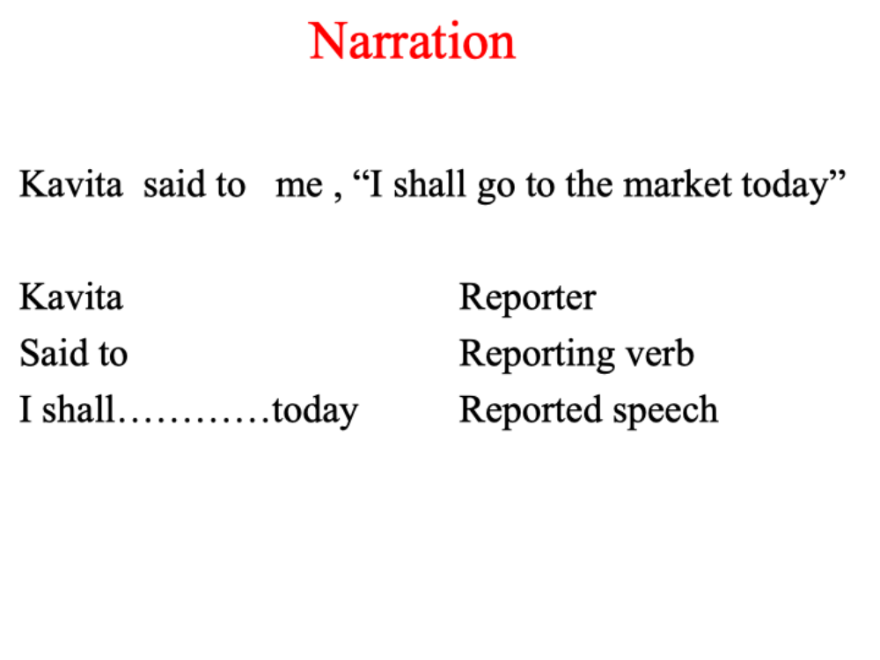
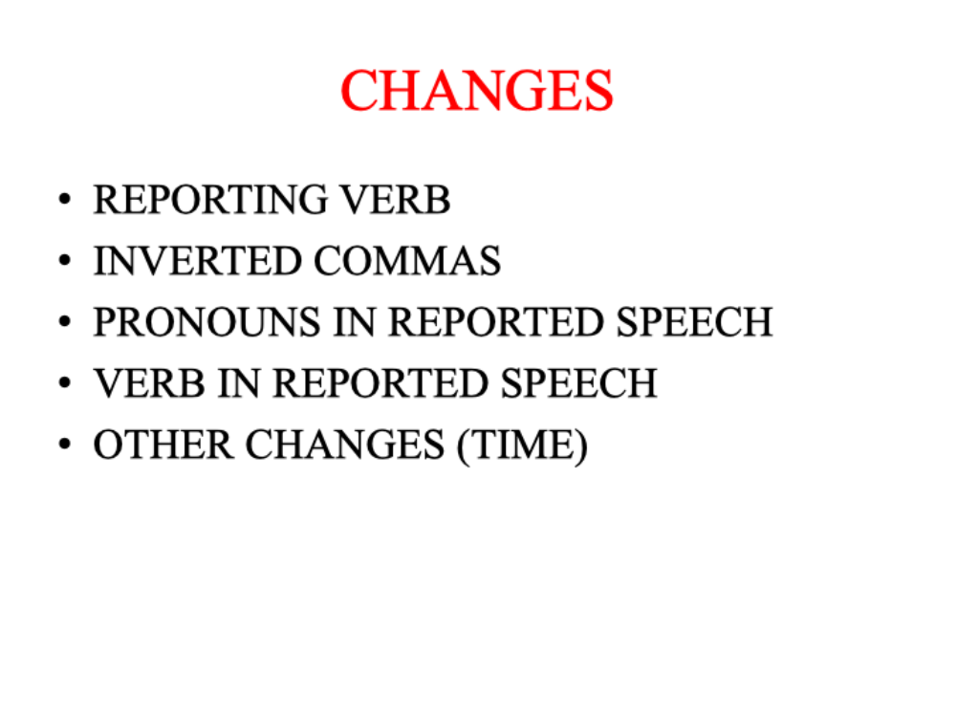
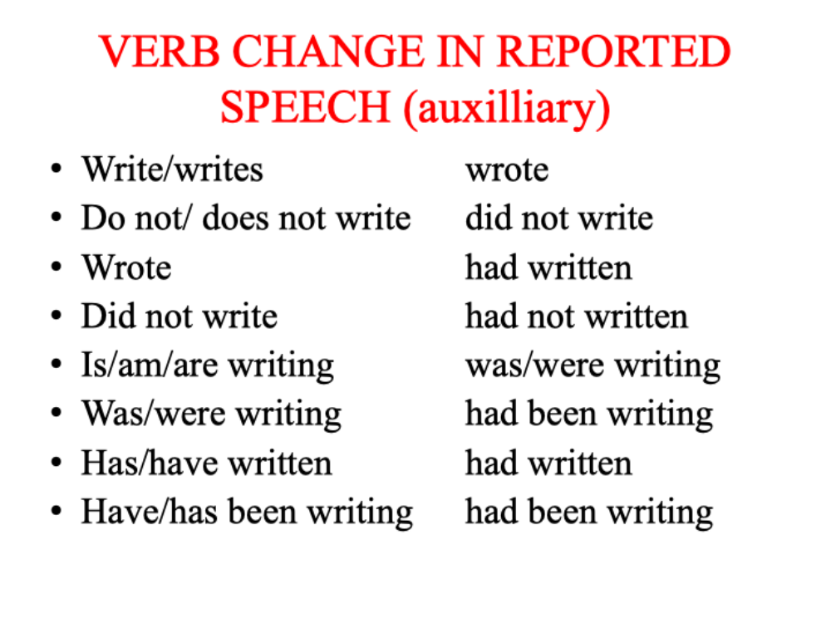
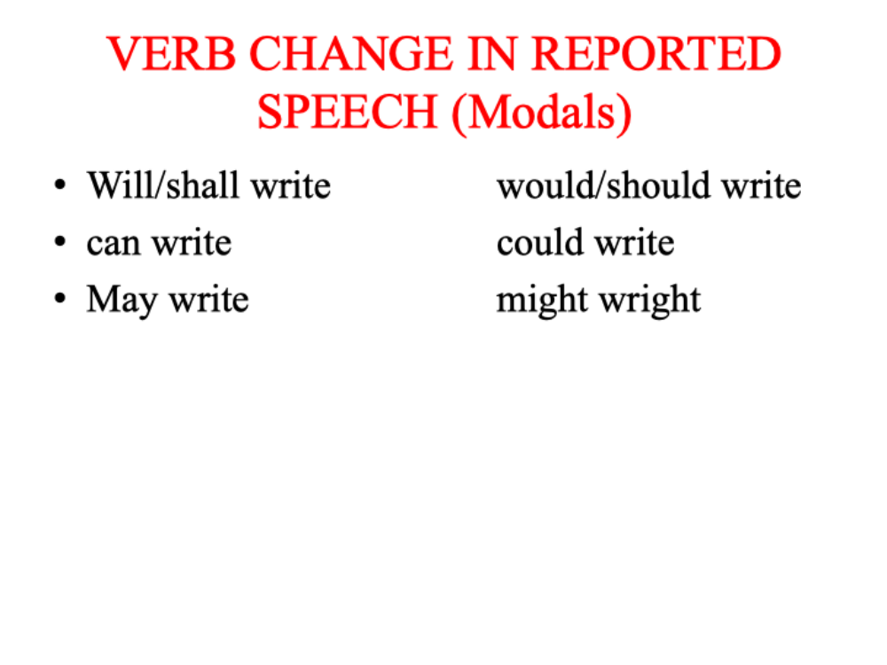
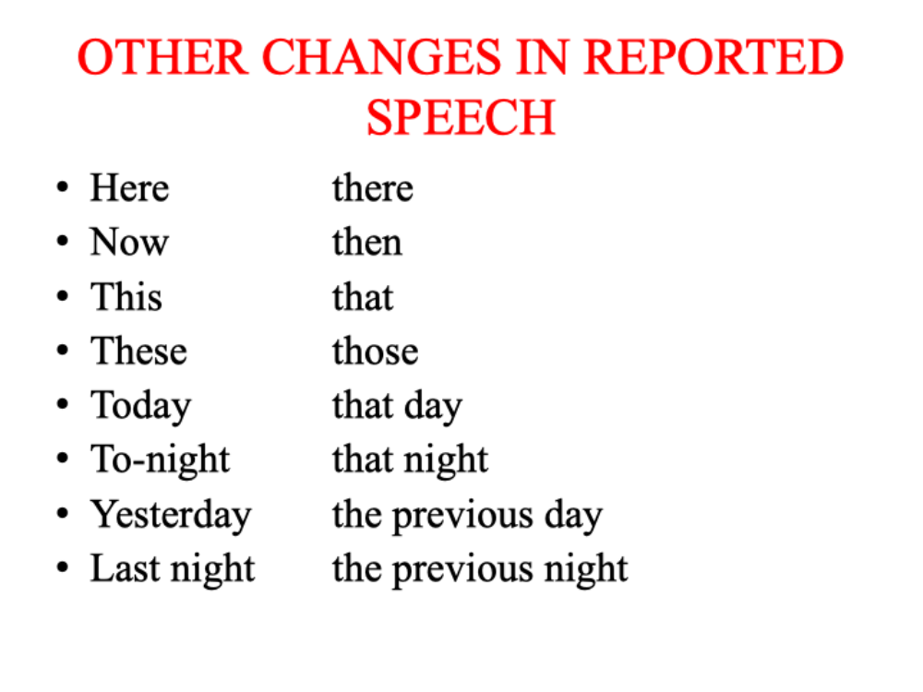
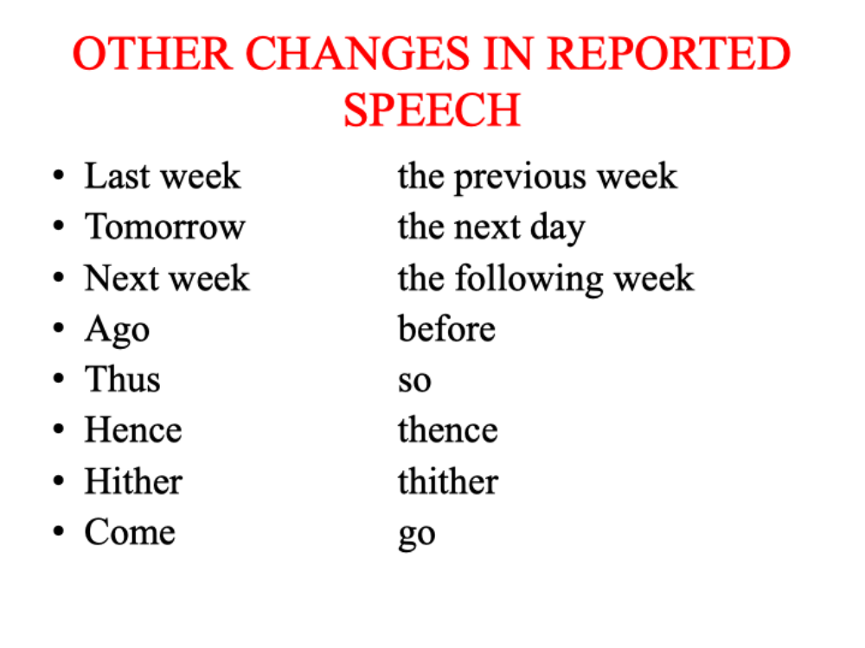
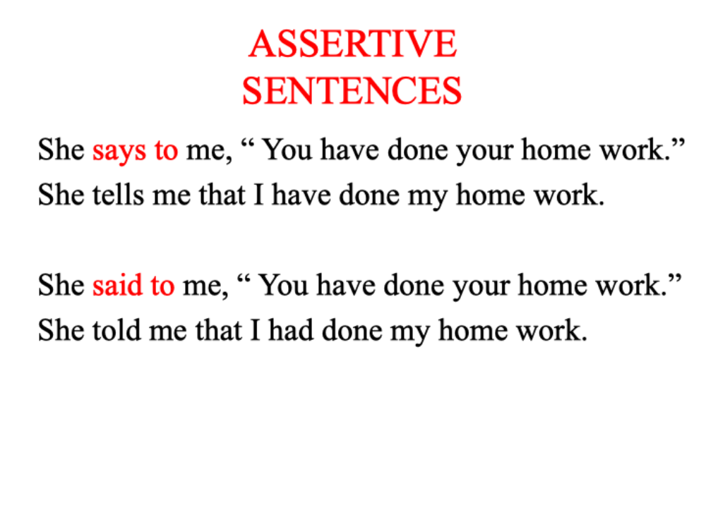
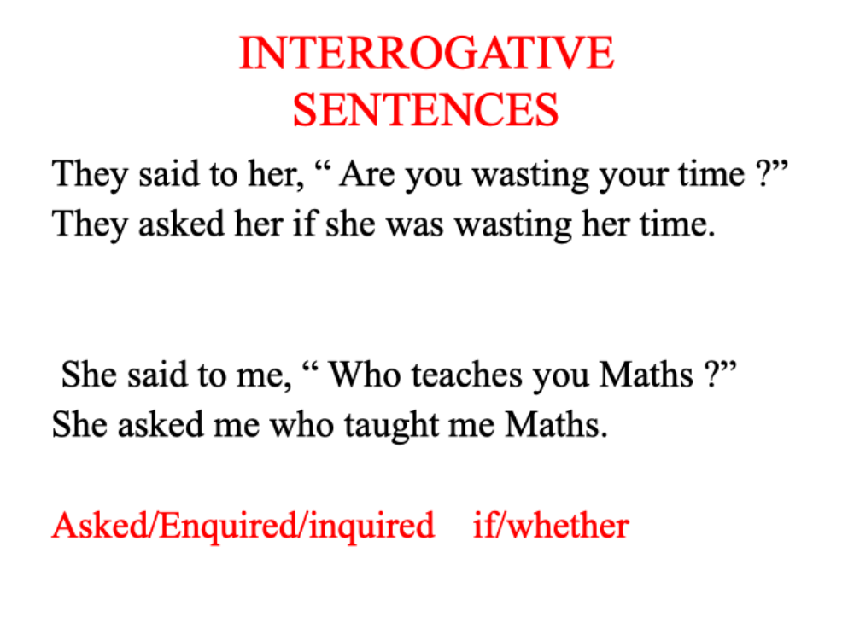
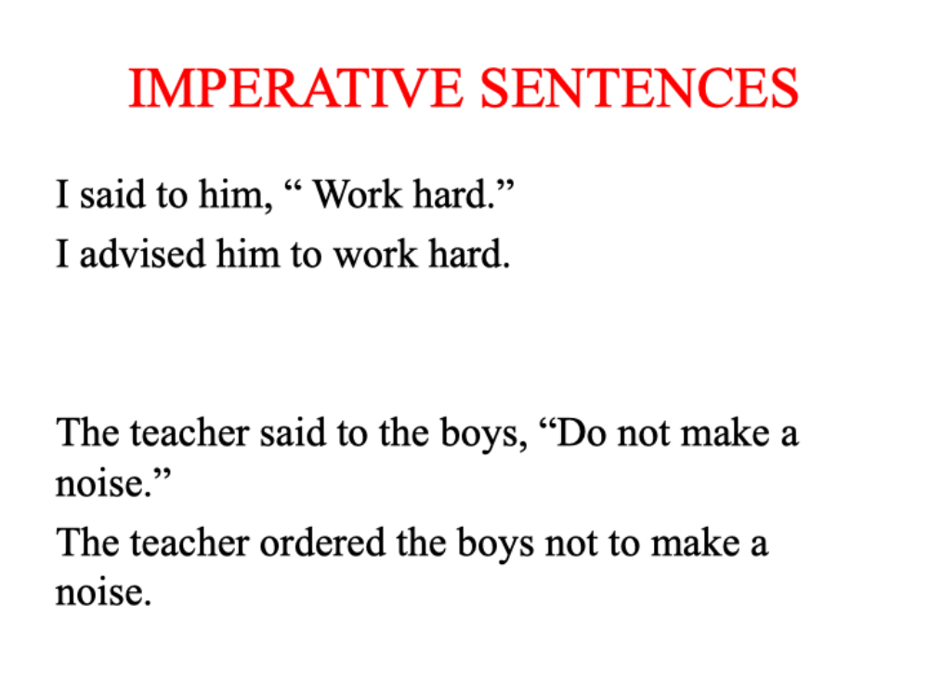
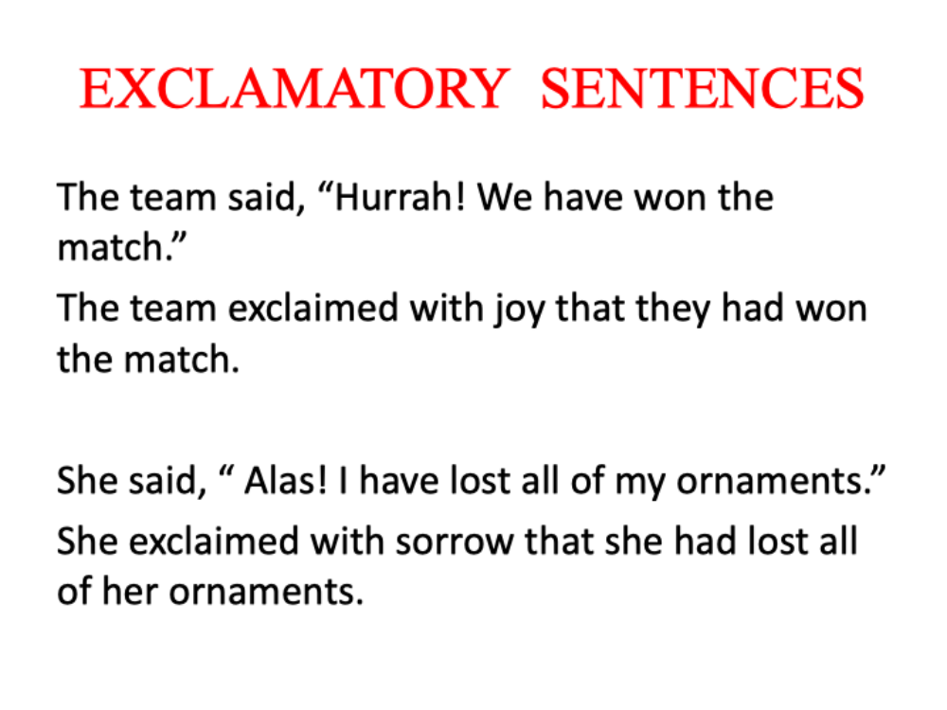
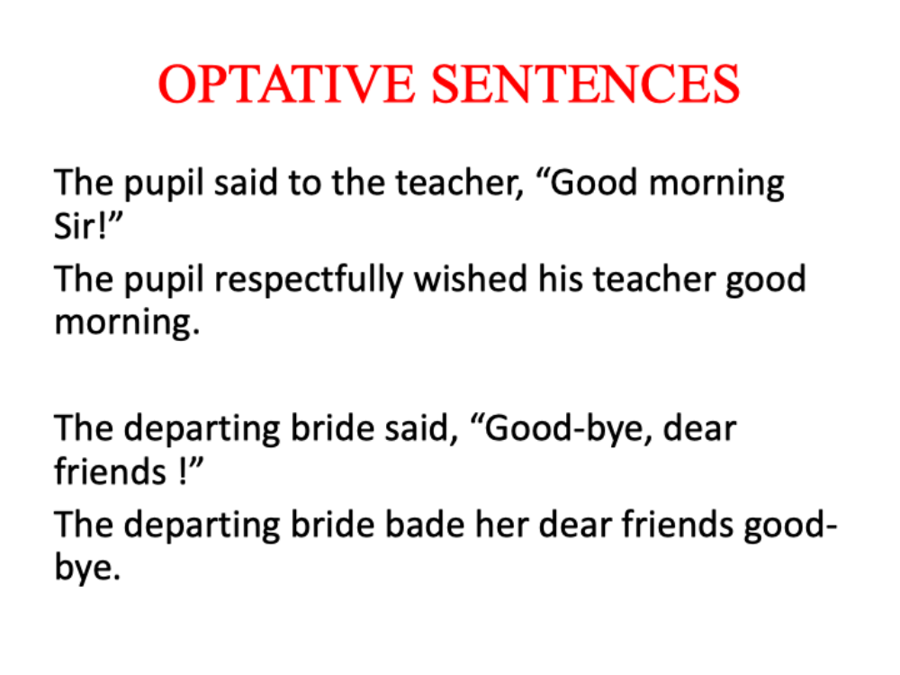
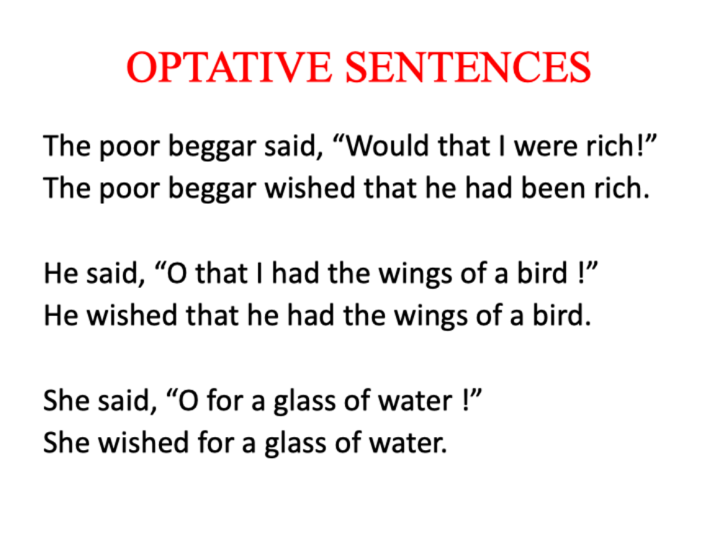

Spotting error and sentence improvement
Spotting errors involves identifying mistakes in grammar, punctuation, sentence structure, or word usage. Sentence improvement means revising sentences to make them clearer, more concise, or more effective. Both skills are crucial for academic, scientific, and professional writing.

Common Types of Errors to Spot

1. Grammatical Errors
- Subject-verb agreement
❌ The data is accurate.
✅ The data are accurate. (“Data” is plural)
- Tense consistency
❌ She completed the experiment and records the results.
✅ She completed the experiment and recorded the results.
- Pronoun reference
❌ When the flask was heated, it broke. (What does “it” refer to?)

2. Punctuation Errors
- Comma splices
❌ The results were significant, they supported the hypothesis.
✅ The results were significant; they supported the hypothesis.
- Misuse of apostrophes
❌ Its a good experiment.
✅ It’s a good experiment. (“It’s” = “it is”)

3. Word Choice Errors
- Wrong word form
❌ The system is very efficiency.
✅ The system is very efficient.
- Misused words
❌ The affect of the drug was notable.
✅ The effect of the drug was notable.

4. Redundancy and Wordiness
- ❌ The reason is because it is important.
- ✅ The reason is that it is important.
(“Reason” and “because” both explain why – redundant.)
- ❌ Due to the fact that...
- ✅ Because...

5. Awkward or Unclear Sentences
- ❌ The sample which was taken from the second batch that was labeled incorrectly was tested.
- ✅ The sample from the mislabeled second batch was tested.

Sentence Improvement Techniques
Problem | Weak Sentence | Improved Sentence
Too vague | The test was done. | The technician performed a stress test on the material.
Passive voice | The report was written by the assistant. | The assistant wrote the report.
Wordy phrase | At this point in time | Now
Unclear reference | This shows that the process is flawed. | The error rate in the data shows that the process is flawed.

✅ Tips for Spotting Errors and Improving Sentences
- Read aloud – Errors and awkward phrasing are easier to hear than see.
- Look for one type of error at a time – e.g., first check subject-verb agreement, then punctuation.
- Use grammar tools or checklists – but don’t rely on them blindly.
- Ask: Can this sentence be shorter, clearer, or more direct?
- Practice regularly – Error spotting is a skill that improves with exposure.

Cloze test
CLOZE TESTS
LEARNING OBJECTIVES
After reading this chapter, you will be able to understand
meaning of Cloze Tests
how Cloze Tests can help improve our language skills
A WORD ABOUT CLOZE TESTS
This chapter will enable you to test, evaluate, and understand how much you have learnt so far. This task has been devised in the form of 25 Cloze Tests. A Cloze Test in English is an empirical comprehension test that is designed to evaluate the learner's understanding of the language. Their purpose is also to help improve
your language skills. In the tests that follow, you will find yourself dealing with small passages each of which will consist of four blank spaces. These are the missing words that you, as a learner, are required to choose
and fill-in from the alternatives provided. The tests are based on concepts which have already been discussed
in the preceding chapters. Since grammar, usage, and vocabulary form an integral part of linguistic compe-
tence, all these tests are meant to provide this additional exposure and practice. An answer key is appended
at the end of each test to help you check your progress in this regard.
Further, since such cloze tests usually form an integral part of the various competitive exams worldwide,
attempting them at this stage should prepare you better for future endeavours. The tests are, therefore, inte-
gral, and as mentioned earlier, give you further practice into various grammatical concepts and new words
discussed in the book.
Each of the following passages consist of a few blanks, which have been serially numbered from 1 to 4.
At the end of the passage, these serial numbers are repeated with each carrying four choices of words marked
a-d. An appropriate option from these alternatives needs to be chosen to fill in the blanks.
CLOZE TEST 1
Passage I
When Mr. Jones died, we went to pay our last .........to him. The............house was in the row opposite..............However, it took us longer to reach there as the street was filled with many visitors...... had come there
.
Options
1. (a) regard (b) regards(c) respect(d) respects
2. (a) Jones'(b) Jones(c) Jone's (d) John's
3. (a) our(b) ours(c) us(d) we
4. (a) who(b) whom(c) that(d) which
Passage Il
Yesterday, a strange thing happened. I was returning from the fair and I saw a jester dancing in a motley dress. Suddenly I was reminded of Shakespeare’s famous fools.

1. (a) happen(b) will happen(c) happened(d) had happened
2. (a) am returning(b) was returning(c) will have to return(d) while returning
3. (a) saw(b) could have(c) see(d) had seen
4. (a) am reminded of (b) will be reminded of b (c) was reminded of
(d) had been reminded of
Passage Ill
Even though we have well and truly stepped into 21st century, we hardly seem to have grown scientific in our temper. Since there is development, education and awareness on one hand, there is poverty, superstition and ignorance on the other. There for the so called education we get, fails to lift the veil of darkness that mostly keeps our vision clouded.Therefore it is too optimistic to believe just by living in an age of science and technology, we have
become developed scientific attitude towards things.
Options

Options
1. (a) When(b) As(c) Even as(d) Even though
2. (a) If(b) Since(c) As well as(b) Moreover
3. (a) Therefore(b) Moreover(c) Whereas(d) Although
4. (a) So(b) Therefore(c) In fact(d) While
Passage
Coming from a gifted dancer, it was a(1) performance. dressed, she immediately grabbed (3) the attention of the audience who kept Adoring(4) her throughout her show.
Options
1. (a) flawed(b) flawless(c) listless(d) jaded
2. (b) astonishing(b) immaculately(c) sporting(d) hopelessly
3. (a) withdrew(b) grabbed(c) overwhelmed(d) engaged
4. (a) overlooking(b) ingratiating(c) placating(d) adoring

Theme detection
Theme detection is the process of identifying the central ideas or underlying messages in a piece of writing. In both literary and technical contexts, a theme is the main subject or concept that the author explores, either explicitly or implicitly.

🔍 What is a Theme?
A theme is:
- The central idea, message, or meaning behind a text
- Not the plot or specific details, but what the text says about life, society, or human nature
- Often expressed in one sentence or a few words

Examples of Themes in Different Texts
Text Type | Possible Theme
Literary (novel/poem) | "Power corrupts" or "The struggle for identity"
Scientific article | "Sustainable energy can mitigate climate change"
Technical report | "Automation improves efficiency in manufacturing"
Speech or essay | "Education is the key to social mobility"

How to Detect a Theme
Here are steps to help identify the theme of any text:

1. Understand the Subject
Ask:
- What is the text about?
- What topics or issues are repeatedly discussed?

2. Look for Repetition and Emphasis
- Are certain ideas, phrases, or problems mentioned multiple times?
- What is being emphasized through characters, data, or analysis?

3. Identify the Author’s Purpose
- Why did the author write this?
- What message or insight are they trying to convey?

4. Examine the Conclusion
- What are the key takeaways?
- What does the author leave the reader thinking about?

5. Summarize in One Sentence
Try to write the theme as a general statement, not a specific detail.
✔️ Good theme: "Unchecked ambition can lead to downfall."
❌ Too specific: "Macbeth’s ambition leads him to kill Duncan."

Practice Example
Text (short passage):
"Despite the risks and isolation, the scientists continued their work in the remote lab, believing that their research could one day save millions."
Possible Themes:
- Dedication to science can come with personal sacrifice.
- The pursuit of knowledge is often driven by a greater good.

Tools for Theme Detection
- Manual reading & annotation: Highlight key ideas and patterns
- AI/NLP tools: Can analyze large texts for keyword frequency and semantic patterns
- Discussion and inference: Talking with others can reveal deeper insights

